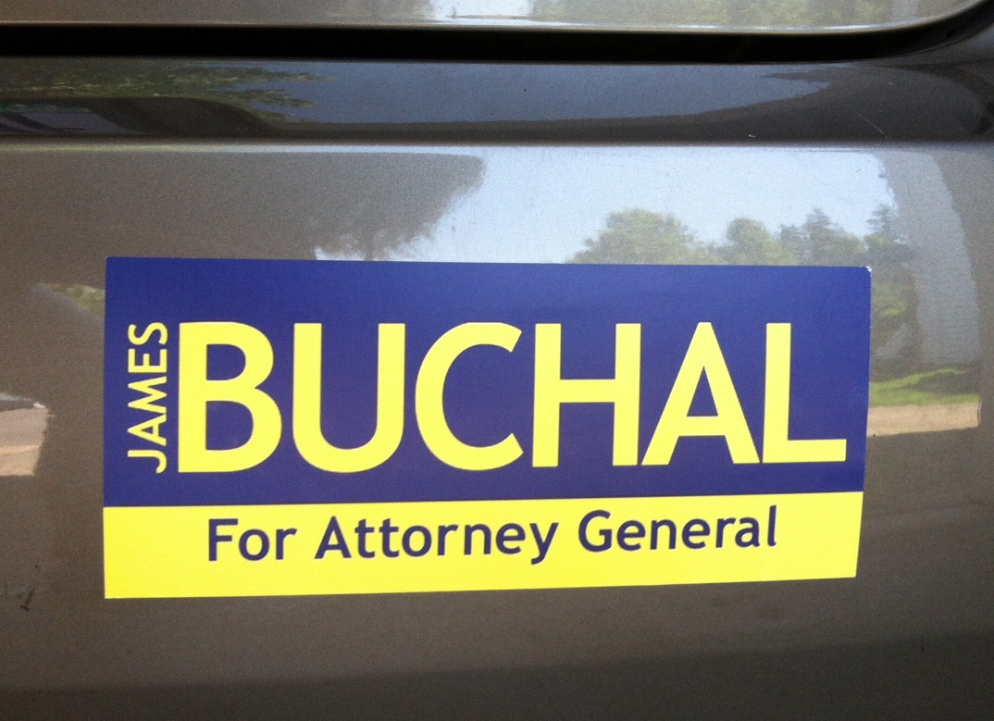
Oregon Attorney General
GOP Nominee
James Buchal

Author of the book
“The Great Salmon Hoax”
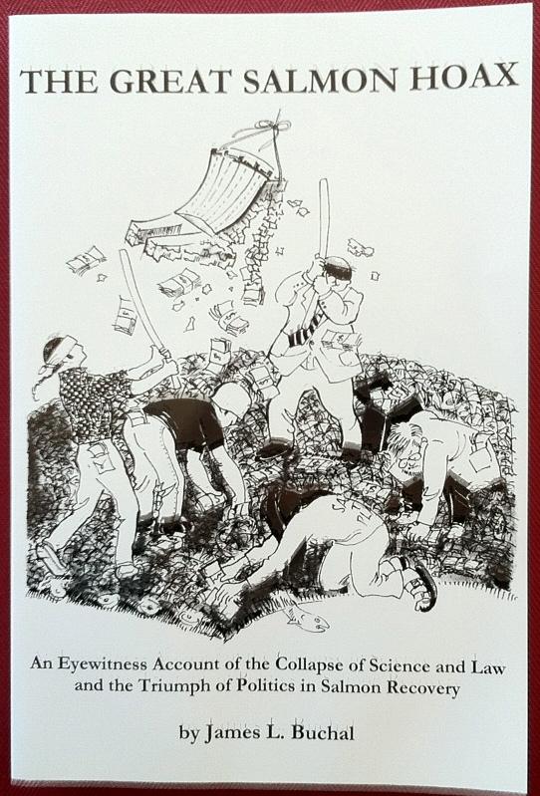

Supporters say:

“Buchal is like a breath of fresh air.”

“Buchal is the best speaker I have ever heard.”

“Finally a candidate who says what needs to be said.”

James Buchal
for Attorney General of Oregon

click on 2 minute video link below
We have got Government Cancer
Youtube video

Itinerary for James Buchal

Saturday 9/22

8:30am
Rally the Pendleton Patriots
Saddle Restaurant
Pendleton

3:30pm
Baker City Freedom Rally
Geiser Grand Hotel
James Buchal will speak to this gathering before the annual Great Salt Lick Auction for Parkinson Disease at 5pm
Baker City

6:30pm
Enterprise Liberty Rally
Wallowa County GOP HQ
108 W River Street
Enterprise, Oregon97828

Sunday 9/23

11am
Church in Klamath Falls

12:30pm
Brunch with Buchal
Elmer’s Restaurant Klamath Falls
Join James Buchal for brunch and hear how James plans to put Oregonians back in charge of Oregon

