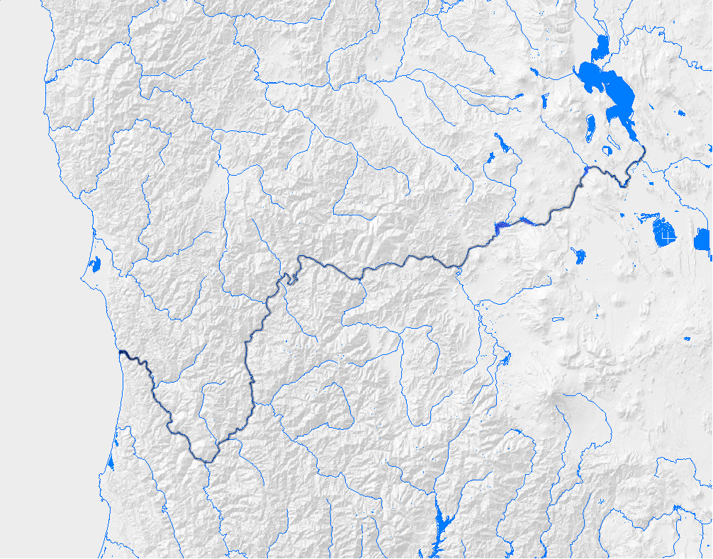
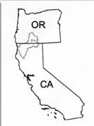
Improving Ecosystem Health to Reduce Disease in Klamath River Salmon
November 26, 2007
Arcata, CA

Problem: The effects of declining Pacific NW salmon populations on coastal economies and tribal communities have been felt for several decades, but the reduction of the commercial catch by 90% in 2006 was a direct result of the weak returns of Chinook salmon to the Klamath River (KR). Severe infection by the myxozoan parasite Ceratomyxa shasta has, in large part, been responsible for the declining numbers of juvenile KR fall Chinook and coho salmon and subsequent impacts on later adult returns. Compared with infection of juvenile Chinook salmon from other Pacific NW rivers, the numbers in the KR are striking. For example, in 2004, approximately 45% of juvenile KR salmon had severe Ceratomyxa shasta infections. Whereas, in the Fraser River, Canada, C. shasta infection prevalence was estimated to be 3.3% and in the Columbia River estuary, C. shasta was detected in 9.6% and 12% of juvenile Chinook salmon in 1983 and 2001, respectively. The high prevalence and severity of C. shasta infections in KR fish indicates this parasite is a key factor limiting salmon recovery in that system.

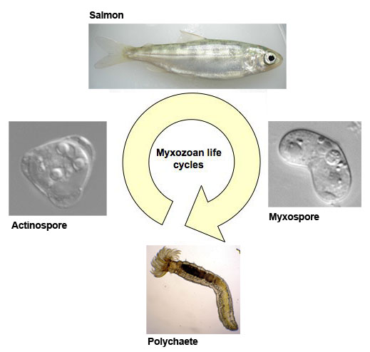
Ceratomyxa shasta has a complex life cycle, involving an invertebrate (polychaete worm) host as well as salmon (see diagram). Salmon in the KR have evolved with C. shasta and are relatively resistant to infection compared to salmon from rivers where the parasite is absent, thus the current severity of ceratomyxosis in these fish suggests a shift in the host:parasite balance. Research conducted by OSU and the US Fish and Wildlife Service (USFWS) have identified a stretch of the river in which high parasite densities and large numbers of infected invertebrate hosts result in severe disease and high mortality, thus providing a target for management actions.

Solution: In 2007, a multidisciplinary panel of fish disease experts and fishery managers met to develop a research plan focused on management actions to reduce disease (ceratomyxosis) in natural juvenile salmon of the KR. This proposed research effort is in addition and complementary to on-going monitoring in the basin. The reach from Iron Gate Dam to the Scott River was identified as the primary management area, based on juvenile salmon infection status and data from fish exposures, invertebrate host surveys and water sampling studies.

Potential management actions would have the goal of:
1. Reducing polychaete host populations in the selected KR reach,
2. Reducing the effects of the infectious actinospore on juvenile salmon,
3. Reducing the input of myxospores from specific salmonid fishes
4. Decreasing fish exposure/Increasing fish resistance

A preliminary ranking of management actions was made based on the likelihood that the action would result in a reduction in ceratomyxosis in natural salmon populations of the Klamath River. Other considerations included the effect on non-target organisms and the ability to monitor effects. The panel recommended several actions as being the most likely to cause a biological effect and as high priority for further research. We propose to test the feasibility of the highest priority management actions through controlled laboratory and field experiments. These studies would be conducted over 2-3 years, leading to large-scale tests or implementation.
1- polychaete

Impacts: Salmon losses in the Klamath basin have had devastating effects on tribal communities along the river and the coastal communities of Oregon and California. The recent closure of the salmon troll industry in 2006 was a management decision in response to the low contribution of the Klamath basin - only 5% of the fishery - with disease being a primary factor. The cost to Oregon coastal communities was estimated to be $28 million dollars in 2006 and Governors of both Oregon and California declared fishery disasters that resulted in allocation of $60 million dollars in federal assistance. Salmon trollers estimate that reducing disease effects by as little as 10% would increase the number of Klamath Rive adult salmon to the point that fishing on that population could resume and allow that industry to survive.

Contributing Panel: The following university and fisheries experts met in August 2007.
Disease Jerri Bartholomew, Oregon State University
Ron Hedrick, University of California, Davis
Gary Hendrickson, Humboldt State University
J. Scott Foott, USFWS CA-NV Fish Health Center
Hydrology Mike Deas, Watercourse Inc.
Fisheries Josh Strange Yurok Tribe
Nicholas Hetrick and Tom Shaw, USFWS Arcata FWO
Mark Hampton, Calif. Dept. of Fish and Game

