GREATER KLAMATH BASIN
STAKEHOLDERS WORKSHOP

Is there any way to deal with the competing demands for water
that recovers the fish, yet sustains and enhances the rural communities?

Can we create fair and equitable solutions?

How can we solve these problems locally, “from the bottom up” rather than “top-down”?

March 16-18, 2005
9-5 Wednesday thru Friday
Tulelake Fairgrounds
Follow the signs to the Home Ec Bldg

Registrations accepted thru March 11
at OSU Extension (541-883-7131)
or e-mail lori.fernlund@oregonstate.edu

$35 registration fee (scholarships available)

Lodging for out-of-town guests provided
at the Winema Hunting Lodge

Facilitation by Bob Chadwick,
Consensus Associates

Sponsored by:
Klamath Compact Commission
OSU Extension, Klamath Falls
Upper Klamath Basin Working Group

Supported by:
Watershed Conference Committee
Ecosystem Restoration Office
Bureau of Land Management, Klamath Falls
Bureau of Reclamation CIP Program
Fremont-Winema National Forest
Bonneville Power Administration

DIRECTIONS
TO THE TULELAKE FAIRGROUNDS

From Klamath Falls, take South 6th Street all the way south through town
Pass Big R on your left, South 6th becomes Hwy 39
Continue south about 20 miles
Turn right at the flashing light at Tulelake onto Main Street
Go about ½ mile to the Tulelake Fairgrounds on the right
Park & follow the signs into the Home Economics Building

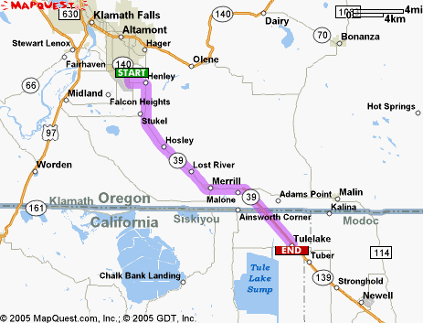

TO THE WINEMA HUNTING LODGE

From Klamath Falls, take Hwy 39 south about 15 miles
Go through the town of Merrill and continue about a mile to Malone Road (see on map)
Turn right & continue 1.7 miles until it Ts at Stateline Road
Turn left & watch for Hill Road on your right
Turn right and continue about 7 miles, past the Tulelake Wildlife Refuge Visitor Center
Winema Hunting Lodge is on your right, 5212 Hill Road
(roughly to the left of the “S” in Tule Lake Sump on the map)

