Letter to the Editor of Pioneer Press, by former and long-time Happy Camp resident and outdoor photographer James A. Waddell, Roseville, CA on May 27, 2010.

Grayback Road is the double lane black-topped FS road over the Siskiyou Mountains from CA to OR that was built by timber sale money in 1965-’66 and improved by several timber sales in the 1970s: Kelly Lake, Sutcliffe and Spees Sales. I lived nearby in the first contract.
In these US Forest Service timber sales, 25% of the sale prices paid to the Forest Service was then paid to Siskiyou County to finance county roads and schools. The Klamath National Forest has 25 billion bf of standing timber that grows 470 million bf of new timber each year! Now! A futile attempt by the Forest Service, against the Wilderness Fanatics’, to sell 20 million board feet of timber each year is only a miniscule amount of 1% of total timber inventory! Less live needles and leaves in trees means less use of carbon dioxide and less conversion to oxygen! Now the Klamath National Forest sells nearly no timber and pays the county nearly no money for roads and schools.
Don’t make more Wilderness or National Monuments where no forest management will occur! The forest does not stop growing to make “Pristine Wilderness”! New trees grow. New hardwood trees grow. New conifer trees grow into dense forest where the lack of management causes the forest to become very thick. Dense new trees, dead logs and thick brush to 20’ high will make fire ladders to carry ground fires… to crown fires… and will runaway in winds of fire!
See the reports of the recent plane crash in the Happy Camp forest when the rescue people could hardly crawl through the 20’ tall, thick brush!
Even when lightning starts fires in small places, they will burn across the ground to lower limbs of young trees and hardwoods to rise into the young timber… to the old timber and make for a crown fire that will run for miles and burn from ground to crowns! Forests are too thick, too dead, a waste of wood, a loss of carbon dioxide conversion in loss of needles… and dangers of many huge wildfires!
Huge wildfires will put more carbon dioxide into the air than millions of cars and trucks! We need healthy, needle bearing forests… not skeletons of dead trees!

James A. Waddell – See following photo article for more information.

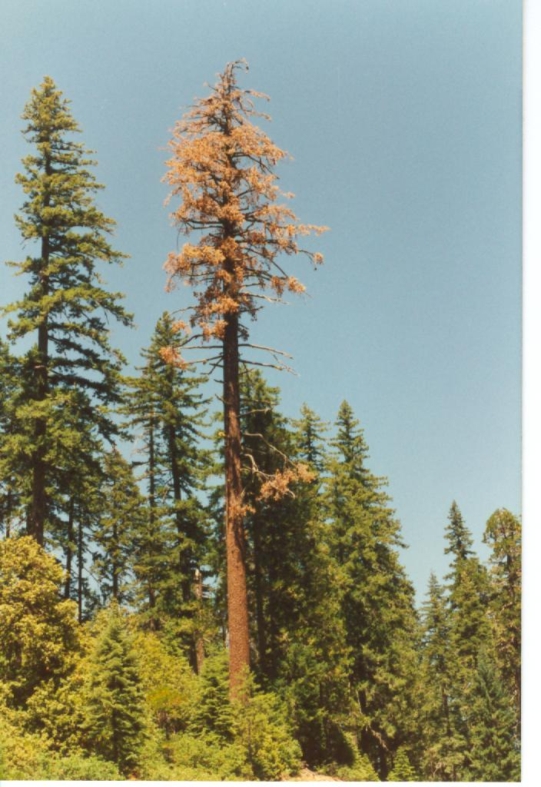
Don’t make more Wilderness or National Monuments where no forest management will occur! The forest does not stop growing to make a “Pristine Wilderness”! New trees grow. New shrubs grow. New hardwood trees grow. New conifer trees grow into dense forest where the lack of management causes the forest to become very thick. Little trees and thick brush to 20’ in height will make fire ladders to carry ground fires to… to crown fires… and will runaway in fires for miles!
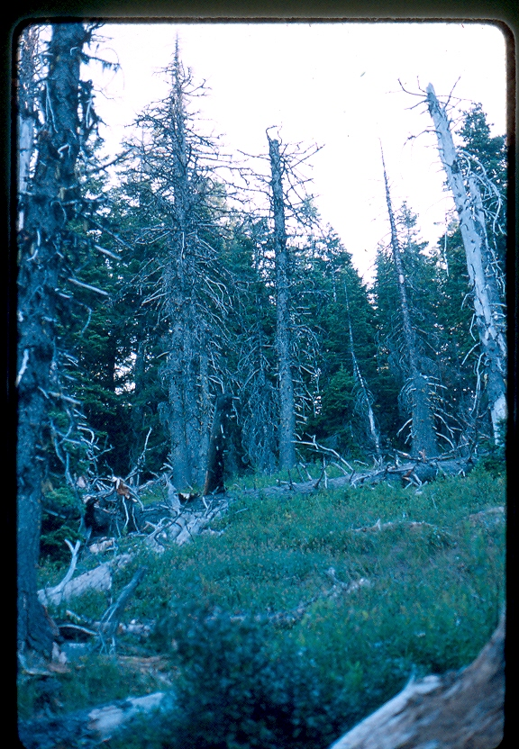
Dead timber on Grayback Mtn both on the left and right… and below left.
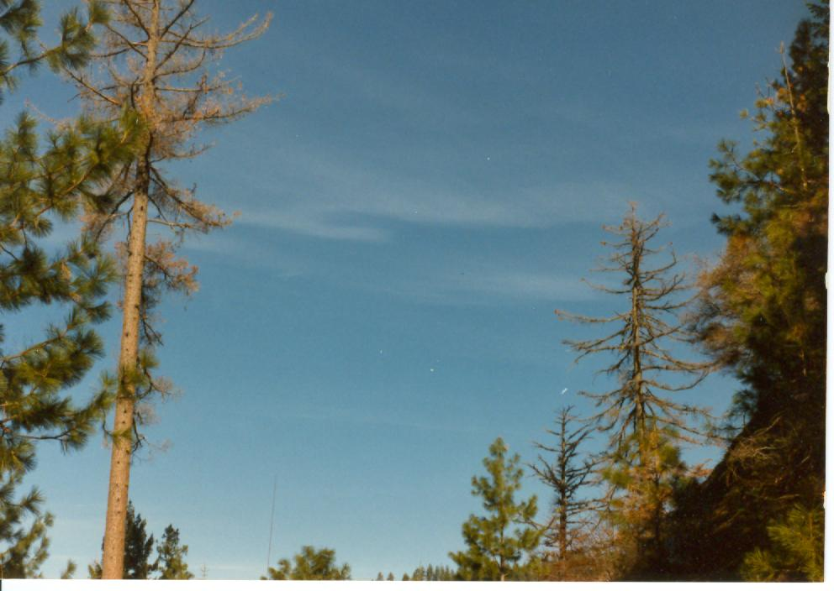
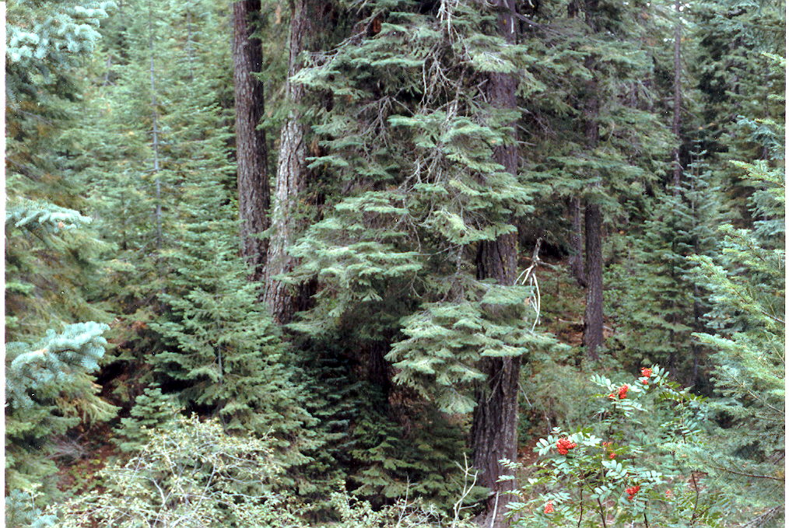
Tall, dead trees are lightning rods! Even lightning started fires in small places will burn across the ground to lower limbs of young trees and hardwoods to rise into the young timber… to the old timber and make for a crown fire that will run for miles and burn from ground to crowns! Forests are too thick, too dead, a waste of wood, a loss of carbon dioxide usage in the needles… and dangers of fast-moving wildfires!
"ROADSIDE SNAG LOGGING"
John Semple Logging Co. of Yreka, CA, on Happy Camp Ranger District, CA
© Copyright By Jim Waddell, Happy Camp, CA 1996.

Monday, January 8, 1996, at 4:00 in the morning I sat writing a letter to the forest service when I heard a big diesel pickup climbing up the Tom Grey road, just across Indian creek from my house. John Semple and Scott Turner were heading up to the Lake Roadside Hazard Salvage Timber Sale.
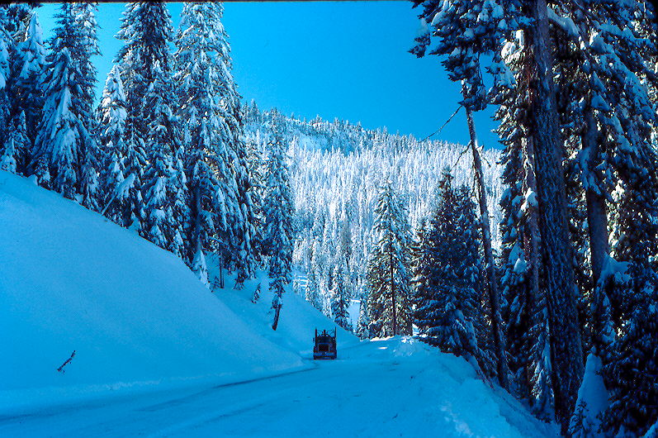
I had talked to John on Saturday about visiting his job on the northwest side of Indian Creek headwaters. I had also talked to him a week or so ago, when it was snowing on top of the Grayback Pass. It seemed like the snow had held off long enough to let him finish cutting roadside trees along the top of this two-lane blacktop between Happy Camp, CA and Cave Junction, OR. The pass and the road are named for Little Grayback Mountain, 6,100 ft. elevation. Smart plan on John's part; get the timber up near the 4,600 foot high pass while he had good weather!
We had decided that Monday would be a good day to visit his salvage logging job. I met John and Scott Turner near Kelly Lake, at the 4,000 ft. level at just after 5:00 a.m. Scott was a young man that chased landing, set chokers, pulled lots of bull-line and quite a few other jobs. This roadside salvage was logging designated dead trees above and below the roads. It takes a lot of ambition and energy to climb up and down the hill for every turn of logs, twice for some. He seemed to be a hard worker. He did complain that as a joke, John called him "Jeff" most of the time. He said he would get even one of these days. John is a good humored man, and is reported to be good to work for. He must have a pretty good sense of humor. He is the only logger I have ever seen that wears purple suspenders and a matching purple "Team Stihl" hat!
It was raining when I left the house, but here on the job, it was only an occasional shower with a light mist coming down most of the time. Up north they'd probably call it a "Washington breeze!"
"Salmon River Sam" George was to be here this morning with his short-logger log truck. If any of you older loggers & truckers remember that name, I think it was Buzz Martin that had a "Salmon River Sam" song on one of his records. Sam said over the CB, "We're runnin' a little late this morning." He had come all the way from his home ranch near Cecilville, CA. As many other good truckers, he would travel far and in many directions to keep hauling enough logs to make a living in this "Timber Country." This vast forest where the forest service has reduced timber sales by about 90%, and reduced the number of timber jobs by about 600. This Klamath National Forest reports their standing timber volume to be 25 Billion Board Feet! It would take a sawmill like Happy Camp about a thousand years to cut that much wood!
John loaded me up with loggin' and truckin' stories while we waited for Sam, and he changed a leaking hydraulic hose on his grapples.
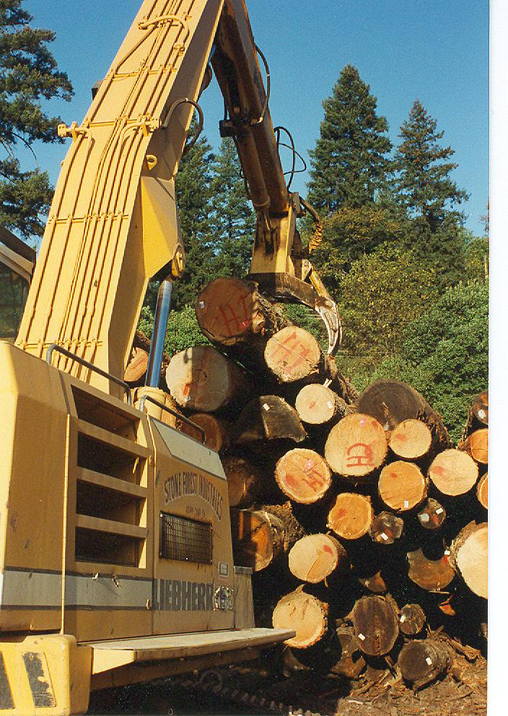
"I've done this quite a few times, I can almost do it without the light," John said while he dug around in the dark for the right wrenches. John had been a log trucker for more than 10 years when one day he decided he wanted to do more than just haul logs. He had traveled from Yreka to Seiad Valley to pick up a load as promised and delivered it twenty miles to Happy Camp, but he couldn't find a load to haul back up river. His pay that day, for him and his Kenworth® self-loading log truck ...was $45! So he stumped around the logging folks in Happy Camp and sold his truck! Sold it on that 45... dollar... day! That was in 1989.
Shortly afterwards, he and his brother Mike bid on a million board foot timber sale called Loop Salvage. Semple Brothers logging Co. was high bidder! "Who-the-hell is Semple Brothers?" was the question asked by log buyers and forest service people.
Well, now they had to come up with about $190,000 cash money to pay initial payments to the forest service, and get equipment ready and moved in. That bit of money he received from selling his truck was a lot short of that kind of money!
Later, hard work, long hours and a good log price from Blue Lake Forest Products paid off for the Semple Brothers Logging. The sale had some big Douglas fir timber and they had some good luck to go with their hard work. They didn't go broke and they had some money left over when they were done! So they set out to do it again.
Later Mike went on to other things and John now works under the name of John Semple Logging. He has bought and logged 18 timber sales...that's right...18 little logging jobs during the calendar year of 1995! His new 1991 Ford® crew-cab pickup has 350,000 miles on it! He worked on the Goosenest District, the Scott River District, the Salmon River District and now the Lake Roadside Hazard Salvage on the Happy Camp District took him into 1996. He bought and logged two "timber sales" that had only ONE tree is each sale! Well..., one of them was 11,270 board feet gross and was hauled out in two loads.
John works with a number of Stihl® chain saws (44's 64's), a Mountain Logger® 150 Rubber tired skidder and a Prentice® 610 hydraulic loader. I asked him if he had a tractor, a Cat® D-7 or something like that. He said no, he has used only a RT skidder and "this ol' Prentice 610". He said that with Butch Hansen running the skidder he doesn't miss having a tractor very much. He has worked a lot of logging jobs, but all of them were skidded with a skidder. Butch is an experienced man out in the woods. I didn't get to talk very him much. He was off working without much delay. He did say he had worked for Rice Brothers for seventeen years and they went down to a one-man outfit several years ago, so I'm sure Butch has more than twenty years experience. John and Scott say that Butch is a topnotch skidder operator and can get the logs out of the woods and onto the landing and make it look quick and easy.
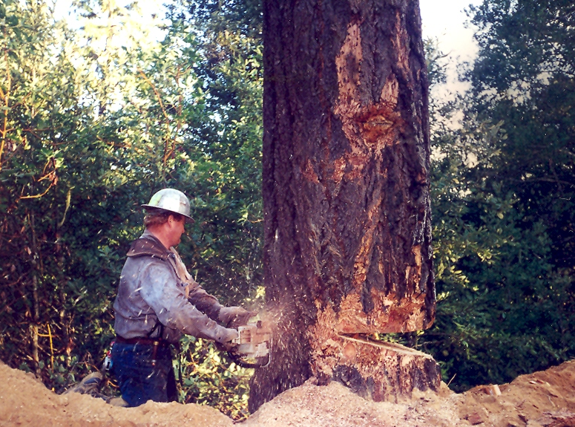
Falling this dead timber, that is scattered from heck-to-breakfast, is a past associate of mine; Dean McBroom, from the Forks of the Salmon, CA area. He and I (and his brother Andy) worked for Croman Corp. at the same time while logging the 55,000 acres of burn in the Salmon River country following the 1977 lightning-caused Hog Fire. (Actually, John worked in that burn too, but he was falling timber for E & A Logging.) Quite a few years had gone by since Dean and I had seen one another, but Dean was just as good a timber faller as I had remembered. I went down the hill with him this morning, (with a Stihl® 44 & Oregon® saw bar, out of the several Stihl® saws in the back of his pickup), while he fell a 3 ft. Douglas fir, two 26 inch Sugar pines, two 4 ft. Sugar pines, and a 30 inch Douglas fir; all snags of course. One of the 4 ft. Sugar pines had lean downhill and Dean wanted to put it up the hill. He looked it over for about a minute and said, "It has a pretty good side-lean..., so I think I can pound some wedges and get ‘her’ up the hill." He did! He and his Stihl® 44 were moving on to the seventh tree after not much more than an hour. Safe, sure, and efficient, that's the kind of faller Dean is; and still alive he pointed out. Falling snags down through other large Douglas fir, White fir, and Sugar pine will give you a heavyweight shower of limbs and chunks if you don't get the heck out of the way. They are called "Widow-makers!"
The Forest Service on this district will not mark a dying tree "if it has one green needle on it." That's the report from John. It's not the best thing to do, leaving trees that are dying and rotting for some other logger to come back to get three or four years later. Many of the trees which Dean is falling and John's crew are logging should have been logged four or five years ago. Sometimes there is no volume of good wood in the trees; all you get is cleanup, (one of those old growth that's been "Preserved" too long, huh!) The cut-out of net volume in some of these little forest service snag sales is 40-60% less than advertised.
This Lake Roadside Hazard Salvage Sale was bigger than most of those John logged in 1995. This one was sold for an estimated 440 Mbf net. John said that by the time he is done on this sale, he will have traveled over 65 to 70 miles of roads on this west side of Indian Creek drainage to gather up all the dead trees painted for cutting. If the forest service had marked other dead, blown-down, and dying trees that are in the salvage area but were not considered a "hazard", this sale could have had four or five times more volume, and the timber wouldn't be going to waste.
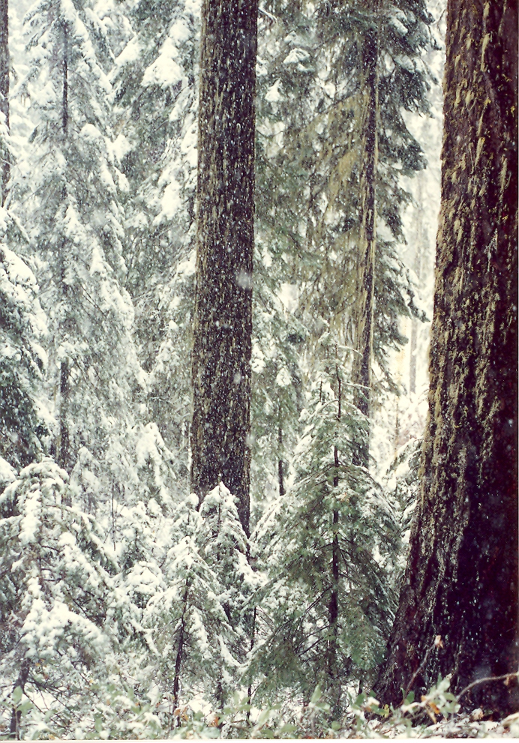
The forest service sold this sale under a 2400-6T lump sum contract. So John had to look this sale over pretty good to make sure of what amount of timber he could get out of it, because under a lump sum sale you pay the forest service all the money that you bid and you get the timber that is marked. If the timber volume under-runs...you don't get any money back. You are faced with an increased rate per Mbf for what timber you do get. John says this sale will overrun, so he will come out alright. But that doesn't seem to happen very often.
Lump sum timber sales are not very good deals. If a logger is too optimistic about rot in the dead timber, he may bid too high and really lose a lot of money. Another logger we know just went broke because the lump sum timber sale that he bought was nearly 60% short of net volume as he neared completion. (It is not unusual to lose $80,000 or $90,000 in such a volume under-run.) A little three or four man "gypo logger" company that went broke for no good reason.
John says that, even with all the running around, he and his crew have been logging 5 or 6 loads per day. Considering all the dead, rotten, scattered out timber, and all the cleanup, that rate of production is something to brag about. This is logging alright, being done by a good crew, but it is more like "survival" than like loggin' we used to know.
I had planned to stop by John's "brush-piling" crew on my way down the mountain. That crew is composed of John's wife Merilee and another hard working lady named Kristi Carlson. I had seen some of their brush piles along the various roads. They do good work. However, they must have been working on another road because I didn't see them on the main haul road. I'll have to get their picture next time around.
Also hauling logs at various times for John Semple is Marc Harding of Orleans, CA, another trucker named Pat Brown, and some of R. B. Brown's trucks from White City, OR. I meet up with Marc often in various places from Roseburg, OR to Redding, CA. He is another hardworking trucker that still does a little bit of loggin' himself at times. He spent quite a bit of time out on the Butt-riggin' and 1 inch chokers in "loggin' of the past". He can tell you some stories of Hi-lead loggin' and trucking when three log loads were a heck of a lot more common. There are millions of big, old, dead & dying trees still out here, except the forest service is "preserving them."
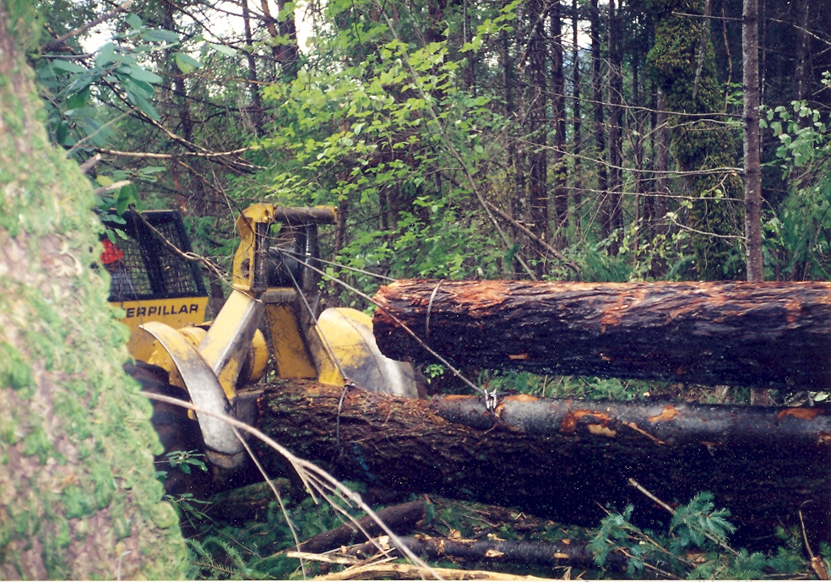
John Semple has a logging crew that is hard working and worthy of a little bragging once in a while. John had their son, Kiawa (5 years old or so) with him this morning. John tells of a time when Kiawa told him, "Daddy, I tired of this dirty ol' loggin'...this loggin' is for babies!”
Signed Jim Waddell. © Copyright by James A. Waddell, 1996. Written for and in cooperation with “American Timberman & Trucker Newspaper… in 1996 and changed photos to the same story text in May 2010. JW Above is a Rubber-tired skidder.
Below is some old and dying timber on the Siskiyou Mtns of Grayback Road.
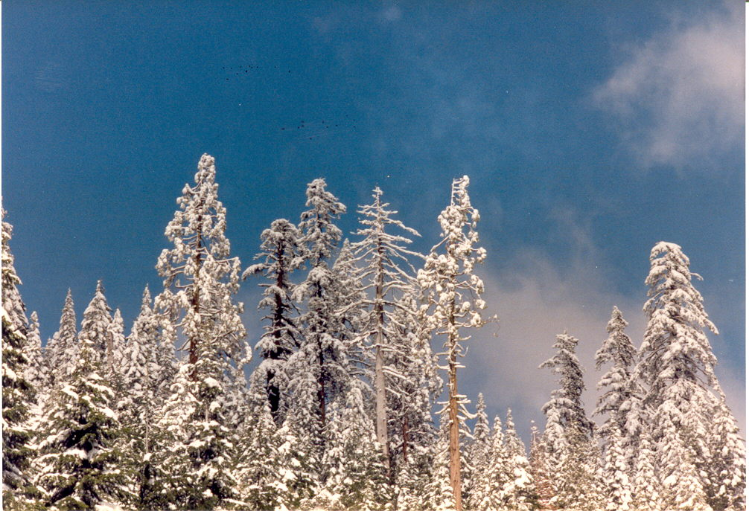
Grayback Road is the full width, double lane black-topped FS road over the Siskiyou Mtns that was built by timber sale money in 1965-’66 and improved by several timber sales in the 1970s: Kelly Lake Sale, Sutcliffe Sale, Spees Sale; all of which had such road work in their contracts. The latter timber sales all used Waddell quarry rock on the main road and the side roads. I was there in management for all timber sales except 1965-’66 original construction; but I saw it.
In all of these US Forest Service timber sales, 25% of the sale prices paid to the FS was then paid to Siskiyou County to finance county roads and schools. Now the Klamath National Forest sells nearly no timber and pays the county nearly no money for roads and schools. Forests too thick, too many dead trees, too much brush! Wildfires!

